China pollution: First ever red alert in effect in Beijing
Schools in Beijing are closed and outdoor construction halted as the Chinese capital's first ever pollution "red alert" came into effect.
The alert, the highest possible warning level, was issued late Monday and will last until midday on Thursday.
Limits have been placed on car use and some factories have been ordered to stop operations.
It comes as China, the world's worst polluter, takes part in talks on carbon emissions in Paris.
It is the first time China has declared a red alert under the four-tier alert system, which was adopted a little over two years ago, although pollution levels were far from the city's worst.
See graphs.
At 07:00 local time on Tuesday (23:00 GMT on Monday), when the alert came into effect, the US Embassy's air pollution monitor in Beijing reported that the intensity of the tiny particles known as PM 2.5 was at 291 micrograms per cubic metre.
By 11:00 it had dropped very slightly to 250 - still a level it described as "very unhealthy". Levels of the poisonous particles in the suburbs were reported at several times that number.

The World Health Organization recommends 25 micrograms per cubic metre as the maximum safe level.
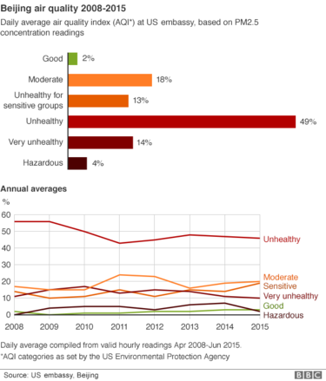

John Sudworth, BBC News, Beijing: "Why red now?"
As I cycled into the office this morning, smog mask clamped firmly in place, the traffic was certainly lighter. Beijing's first red alert means half of all cars must stay off the roads; odd numbered license plates today, even numbered ones tomorrow.
But although the air is indeed an unpleasant, filthy grey, the pollution index is actually a good deal lower than it was this time last week, when the quantity of dangerous particulate matter (PM 2.5) surged to around 40 times the World Health Organisation's maximum guideline. Today, it is a mere 10 times that limit.
So why red now? Well, the lack of any previous red alerts has been met with increasingly loud howls of derision. What would it take, people wondered last week - as their children felt their way to the still open schools through the poisonous gloom - for the government to act?
Perhaps it is the growing public pressure that has finally made the difference this time round.
Coal-powered industries and heating systems, as well as vehicle emissions and dust from construction sites, all contribute to the smog which has been exacerbated by humidity and a lack of wind.
The order will last until 12:00 on Thursday, when a cold front is expected to arrive and clear the smog.
As well as limits on construction and schools - which were advised to close if they did not have good air filtration systems - cars are only permitted to drive on alternate days, with the day depending on whether a car's number plate ends in an odd or even number. Officials promised additional public transport to cope with demand.
Analysis: Matt McGrath, BBC environment correspondent, Paris
China's air quality is a key factor in its push for a new global deal on climate change.
Its negotiators here point to their continued investment in renewable sources of energy, in an effort to cut down on coal consumption, particularly in urban areas. Around 58% of the increase in the country's primary energy consumption in 2013-14 came from non-fossil fuel sources.
These efforts to go green may not be having an immediate effect on the air in Beijing but they have had an impact on global output of carbon dioxide. This year's figures, just published, show carbon levels have stalled or declined slightly even while the world economy has expanded.

A strong agreement here in Paris won't immediately solve China's air woes, but if it ultimately pushes down the price of renewables even further, it could play a part in solving the issue long term.
"You have to do whatever you can to protect yourself,'' Beijing resident Li Huiwen told AP news agency. "Even when wearing the mask, I feel uncomfortable and don't have any energy.''
While the smog's effects have been worsened by weather conditions and the city's geography - bordered to the south and east by industrial areas that generate pollution and to the north and west by mountains that trap it - it has prompted increasing concern that China has prioritised economic growth at too high an environmental cost.
"It is a sharp warning to us that we may have too much development at the price of environment and it is time for us to seriously deal with air pollution,'' said Beijing worker Fan Jinglong.
The scale of the health impact is vast. There have been 1.4 million premature deaths in China because of air pollution, according to a study led by Jos Lelieveld of Germany's Max Planck Institute and published this year in Nature magazine.

What are PM 2.5 particles?
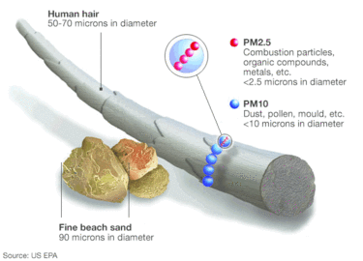
- Particulate matter, or PM, 2.5 is a type of pollution involving fine particles less than 2.5 microns (0.0025mm) in diameter
- A second type, PM 10, is of coarser particles with a diameter of up to 10 microns
- Some occur naturally - e.g. from dust storms and forest fires, others from human industrial processes
- They often consist of fragments that are small enough to reach the lungs or, in the smallest cases, to cross into the bloodstream as well

Activists said the level hit 1,400 micrograms per cubic metre in the north-east city of Shenyanglast month, saying it was the worst seen in China.
In comparison, London's PM 2.5 average on 6 December was 8 micrograms per cubic metre, the Environmental Research Group at King's College said. It said more than 70 was reached during spring 2014 and 2015, and the highest was on bonfire night, 5 November 2006, at 112.
Last week, activists from Greenpeace had urged the Chinese government to declare a red alert. Another Chinese city, Nanjing, issued a red alert in December 2013.
On 30 November, Beijing issued an orange alert - the second-highest of the four-tier system adopted in 2013.
Pollution in the capital had in fact improved in the first 10 months of the year compared with the same period last year, although pollution levels were still frequently high.
Correspondents say Chinese officials had been unwilling to commit to hard targets on reducing carbon emissions, but have now realised the country has to cut its dependence on fossil fuels. President Xi Jinping promised to take action over China's emissions at the global climate change talks in Paris.
China still depends on coal for more than 60% of its power, despite major investment in renewable energy sources.

