Important Figures in Latin America

Simon Bolivar (1783-1830)
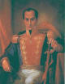
Simon Bolivar was born into a Creole family in Venezuela in 1783. He was the leader of the Latin American Revolution in South America. He was involved in the liberation of Venezuela, Peru, Ecuador, Bolivia, and Colombia. The freed people of Latin America knew him as El Liberator.
Charles III (1716-1788)
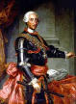
Charles III was the son of Phillip V and Elizabeth Farnese. During the 1760's he began issuing reforms in an effort to regain economic and political control of the Spanish Colonies. He was regarded as one of the greatest Bourbon Kings.

Jose De San Martin (1778-1850)
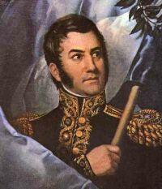
Jose De San Martin was born in Argentina and was given the title of Knight of the Andes by the Argentinian people. He was involved in the liberation of Argentina from the Spanish Empire and was a master of military strategy which led to many major successes.

Bernardo O'Higgins (1778-1842)
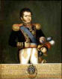
Bernardo O'Higgins was the son of an Irish engineer and a Chilean aristocrat. He lead several battles against Chileans royalists where he distinguished himself through his courage. He allied himself with Jose De San Martin and the two of them marched over the Andes and retook Chile. He also took part in the liberation of Peru in 1821.
Agustin de Iturbide (1783-1824)
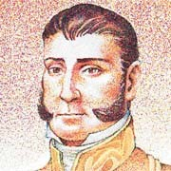
Agustin de Iturbide was a supporter of Mexican Independence who was an officer in the royalist army. He even helped put down a revolt lead by Moreles y Pavan. Later he took a command of troops from Viceroy Apodaca under the guise of fighting Vincente Guerrero. After the two met on the field of battle they conspired against the Spanish Crown. Agustin lead his troops against the Spanish quickly overthrowing them. He became the Mexican King from 1822-1823 before he was dethroned.

