On June 28, 1914, a Bosnian nationalist assassinated Austria-Hungary's Archduke Franz Ferdinand and his wife, Sophie, in Sarajevo. These shootings touched off a series of events that led to World War I.
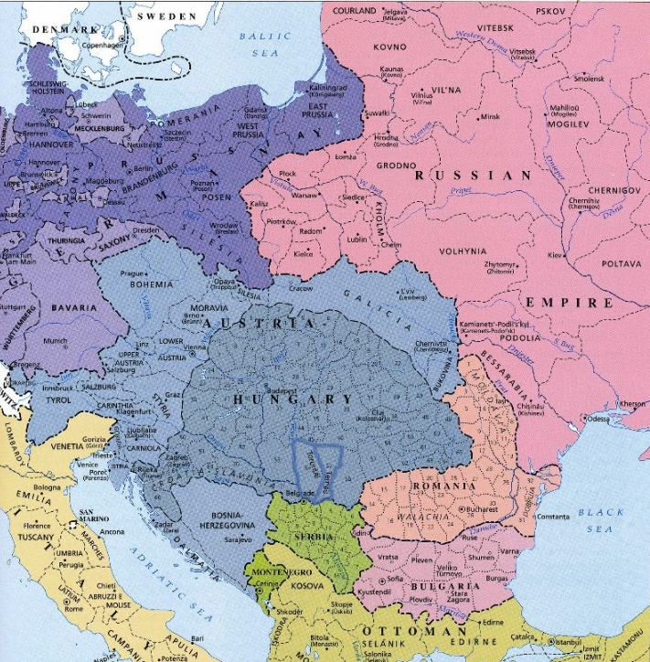
The Austro-Hungarian Empire had grown throughout the later part of the 1800s and 1900s, adding Bosnia and Herzegovina in 1908 and further dividing the larger area's Eastern European population. Tensions were fierce with neighboring Serbia, which had ambitions of its own. A group of Serbian secret military operatives calling themselves the Black Hand had formed just after the turn of the century, with the goal of promoting a united nation similar to what Italy and Germany did back in the 1800s. The annexation of Bosnia fueled the Black Hand's anger, and a subgroup led by Danilo Ilic embarked on a plan to kill the new governor of Bosnia, Oskar Potiorek. Soon, the organizers expanded the plan to include the heir to the imperial throne, Franz Ferdinand.
June 28 was a day of nationalist pride in Serbia, marking a Serbian military victory dating back to the 14th Century. Nonetheless, Franz Ferdinand chose that day to inspect Austrian troop maneuvers in the Bosnian capital, Sarajevo. The assassination was a coordinated plan. The Archduke had announced the date of his visit well in advance. Ilic planned for seven men in all to attempt to kill Franz Ferdinand.
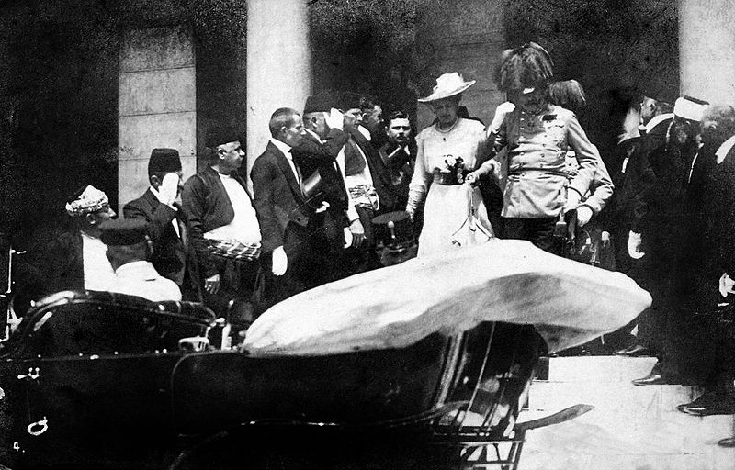
As a show of force, the Archduke ordered a parade through the heart of Sarajevo. The plan was for the royal procession to wind from the train station to City Hall, for a royal welcome, and then to the military parade grounds, so the Archduke could inspect the troops. The parade route was announced publicly.
Franz Ferdinand and his wife, Sophie, rode in the third car, behind a car containing security officers and a car containing the Sarajevo mayor and chief of police. The royal couple rode in an open-topped car. Behind them was a car containing Austrian military officers. A dispute over the appropriateness of military uniforms kept the Austrian army from lining the parade route, and the local police was thin on the ground. Crowds of civilians were large. Several assassins lined the parade route, and one of them was ultimately successful.
The first two would-be assassins were unable to throw their weapons of choice, bombs, because it was too crowded. The third would-be assassin, a man named Nedeljko Cabrinovic, threw an armed grenade at Franz Ferdinand's car. Franz Ferdinand himself knocked the grenade out of the car, and the grenade exploded under the next car in line, injuring two army officers. The man who threw the grenade, seeing his failure, took a cyanide (poison) pill, but the poison was so old that it merely sickened him, making him weak enough to be unable to avoid being arrested by local police. Following the explosion, the Archduke's procession sped to City Hall, where the royal party settled down enough for both the governor and the Archduke to give a speech.
The intended route away from City Hall was changed when the Archduke and his wife expressed an interest in visiting the hospital to see those injured in the explosion. The change to the publicized route meant that the other would-be assassins were no longer in prime position to carry out their attacks. The lead driver, however, didn't get the word of the change in route and, when he noticed he was going in what he thought was the wrong direction, stopped and then tried to reverse direction. In the confusion, another conspirator, Gavrilo Princip, walked up to the royal car and fired shots from a revolver, hitting Franz Ferdinand in the neck. Bosnian Governor Potiorek was the next target but escaped harm when an ensuing struggle altered Princip's subsequent shots, resulting in a stomach injury to Sophie. Princip also swalled a cyanide pill; this pill failed to work, and Princip was held by the crowd until police arrived.
The royal couple died shortly thereafter. It was their wedding anniversary.

- Explain the relationship between Austria-Hungary, Serbia, and Bosnia.

- Evaluate the decision of Franz Ferdinand to visit Bosnia on June 28th. Was this a poor choice? Why or why not?

- Would you describe the Black Hand as a terrorists or patriots? Explain

- You are Austria-Hungary, your future King and Queen were just assassinated while visiting one of your territories. People from that territory and its neighbor were the murderers. What would you do?

- Follow up question. You are Austria-Hungary, your future King and Queen were just assassinated while visiting one of your territories. People from that territory and its neighbor (who has an alliance with RUSSIA) were the murders. What would you do?

- The bullet that hit Franz Ferdinand is located in a museum today in the Czech Republic and is described as “The bullet that started World War I.” Is this description accurate? Why or why not?

