Totalitarianism
Defintion: a government system in which the state has absolute or total authority and regulates every aspect of its citizen’s life (public and private).
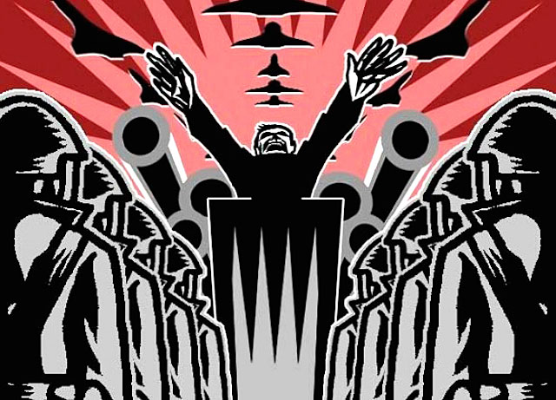
Characteristics:
- Dictatorship- a single political party establishes complete control of all aspects life (political, military, economy, social, and cultural).
  - State demands loyalty and denies basic liberties

- Strong, dynamic leader at the head of the government
  - Often very charismatic
  - A symbol of government

- Highly nationalistic
  - Flags, salutes, rallies, and uniforms

- Common ideology- a common set of beliefs the people are expected to follow
  - total conformity of people to goals and ideas of the state and the leader
  - used to justify government actions

- Employees methods of control
  - Police Terror: the government uses police to spy on, intimidate people, use brutal force or even murder people to inforce the will of the state
  - Indoctrination: the government shapes people’s minds through slanted education (uses schools and youth organizations)
  - Media Control: the government controls all mass media (newspapers, radio)
    - Propaganda- the spreading of ideas, information, or rumor for the purpose of helping or injuring an institution, a cause, or a person
      - crushes opposing views and uses the arts to promote views
    - Censorship: an official reads communications and deletes material considered sensitive or harmful
      - Blocks opposing views or messages that would damage the image of the state from the public
      - No form of speaking out against the government is allowed
  - Religious or Ethnic Persecution:
    - Leaders of various religious, ethnic minorities “enemies of the state” -exiled or killed
    - Churches are destroyed
    - In extreme cases this could lead to genocide

Examples:
- Nazi Germany under Adolf Hitler
- Soviet Russia under Joseph Stalin
- Fascist Italy under Benito Mussolini
- North Korea under the Kim dynasty

