7th Unit 2 – Operations with Rational Numbers
Performance Task 5
Standard(s) Addressed:
7.NS.1 Apply and extend previous understandings of addition and subtraction to add and subtract rational numbers; represent addition and subtraction on a horizontal or vertical number line diagram.
d. Apply properties of operations as strategies to add and subtract rational numbers.

7.NS.2 Apply and extend previous understandings of multiplication and division and of fractions to multiply and divide rational numbers.
- Understand that multiplication is extended from fractions to rational numbers by requiring that operations continue to satisfy the properties of operations, particularly the distributive property, leading to products such as (–1)(–1) = 1 and the rules for multiplying signed numbers. Interpret products of rational numbers by describing real-world contexts.
- Understand that integers can be divided, provided that the divisor is not zero, and every quotient of integers (with non-zero divisor) is a rational number. If p and q are integers, then –(p/q) = (–p)/q = p/(–q). Interpret quotients of rational numbers by describing real-world contexts.
- Apply properties of operations as strategies to multiply and divide rational numbers.
Convert a rational number to a decimal using long division; know that the decimal form of a rational number terminates in 0s or eventually repeats.

7.NS.3 Solve real-world and mathematical problems involving the four operations with rational numbers.

Standards for Mathematical Practice:
MP 3: Construct viable arguments and critique the reasoning of others.
MP 4: Model with mathematics.
MP 5: Use appropriate tools strategically.
MP 6: Attend to precision.
MP 8: Look for and express regularity in repeated reasoning.

Task: You have been given the opportunity to become either a recipe maker or a party planner. Choose one of the options and follow the directions below.

Recipe Maker | Party Planner
- Find an original family recipe that serves between 4-8 people. The recipe must have at least 5 ingredients. You can ask a family member for the recipe or you can find one on the Internet.  - Modify the recipe to serve half of the original people.  - Modify the recipe to serve 30 people.  - Modify the recipe for a single serving. | - Plan a party for 4-8 people using to-go menus from restaurants or online. Make sure to include: a protein, a salty snack, a healthy snack, drinks, and a dessert. Calculate the cost of planning a party for 4-8 using the items you selected above.  - Calculate the cost of planning a party for half of the original amount people.  - Calculate the cost of planning a party for 30 people.  - Calculate the cost of planning a party for 1 person.

After you have selected one of the options from above you will create a presentation on either PowerPoint or Google Slides to showcase your work.

If you chose the Recipe Maker your presentation must include:
- A slide with the original recipe that includes the ingredients and baking directions. If you found your recipe online you must give credit to the source where you found the recipe.
- A slide with the modified recipe to serve half of the original people.
- A slide with the modified recipe to sere 30 people
- A slide with the recipe for a single serving.
- Make sure to provide detailed explanations of your calculations. You can either have a separate slide to show all of your work or you can provide the explanations on the slides with the modified recipes.
- Make sure your presentation is neat and creative. Include pictures of the ingredients and/or finished product.

If you chose the Party Planner your presentation must include:
- A slide with the menu you have selected for the 4-8 people attending your party. If you chose items from different restaurants make sure to specify where each piece of food is coming from.
- A slide with the calculations for the cost of planning a party for 4-8 people.
- A slide with the calculations for the cost of planning a party for half of the original amount of people.
- A slide with the calculations for the cost of planning a party for 30 people.
- A slide with the calculations for the cost of planning a party for 1 person.
- Make sure to provide detailed explanations of your calculations. You can either have a separate slide to show all of your work or you can provide the explanations on the slides you created for the various amounts of attendees.
- Make sure your presentation is neat and creative. Include pictures of the to-go menus or the items you have selected for your party.

Solution and Rubric: The difference between the two options is that with the Recipe Maker the students are required to do calculations with fractions, whereas with the Party Planner the students are required to do calculations with decimals. By allowing students to choose between the two options the teacher is able to provide the students with an opportunity to take charge of their own learning. Below is an example of a student’s project for the Recipe Maker option. Although this student did not provide any graphics; they did have the correct modifications for each serving size, as well as explanations of their calculations.
Level I | Level II | Level III | Level IV
Student demonstrates limited or no understanding of operations with rational numbers. The solutions do not address any of the mathematical concepts in the task and there is no explanation of the solution. The presentation does not have the correct number of slides and there are no graphics. | Student demonstrates a vague understanding of operations with rational numbers. The solutions address some, but not all the mathematical concepts presented in the task. Where required explanations are incomplete or not clear. The presentation does not have the correct number of slides and there are no graphics. | Student demonstrates a nearly complete understanding of operations with rational numbers. The solutions address almost all of the mathematical concepts presented in the task. Minor errors may exist. Where required there is a clear explanation of the solution. The presentation has the correct number of slides, but there are no graphics. | Student demonstrates complete understanding of operations with rational numbers. The solutions completely address all mathematical concepts presented in the task. Where required there is a clear, proficient explanation of the solution. The presentation has the correct number of slides and includes graphics.

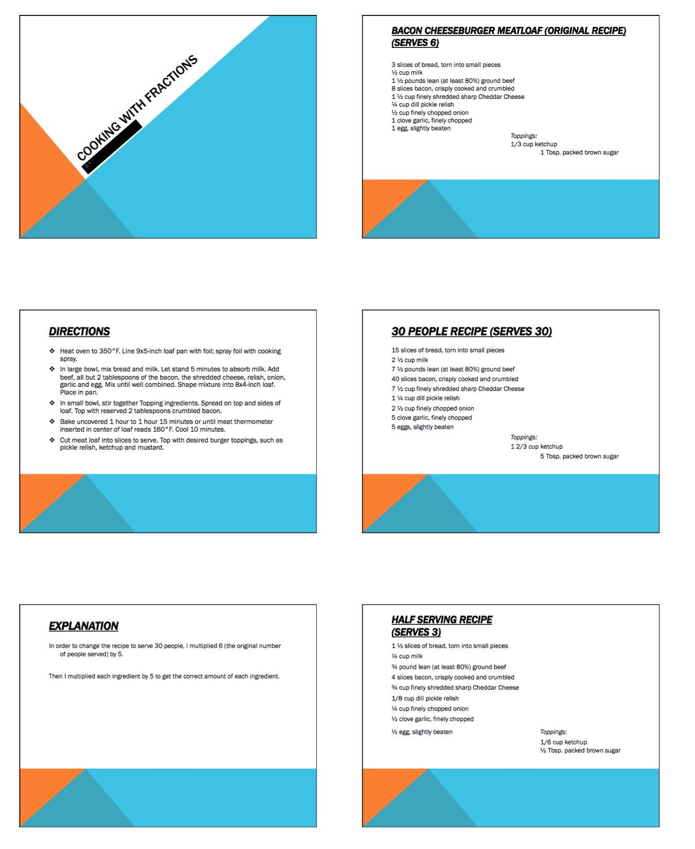
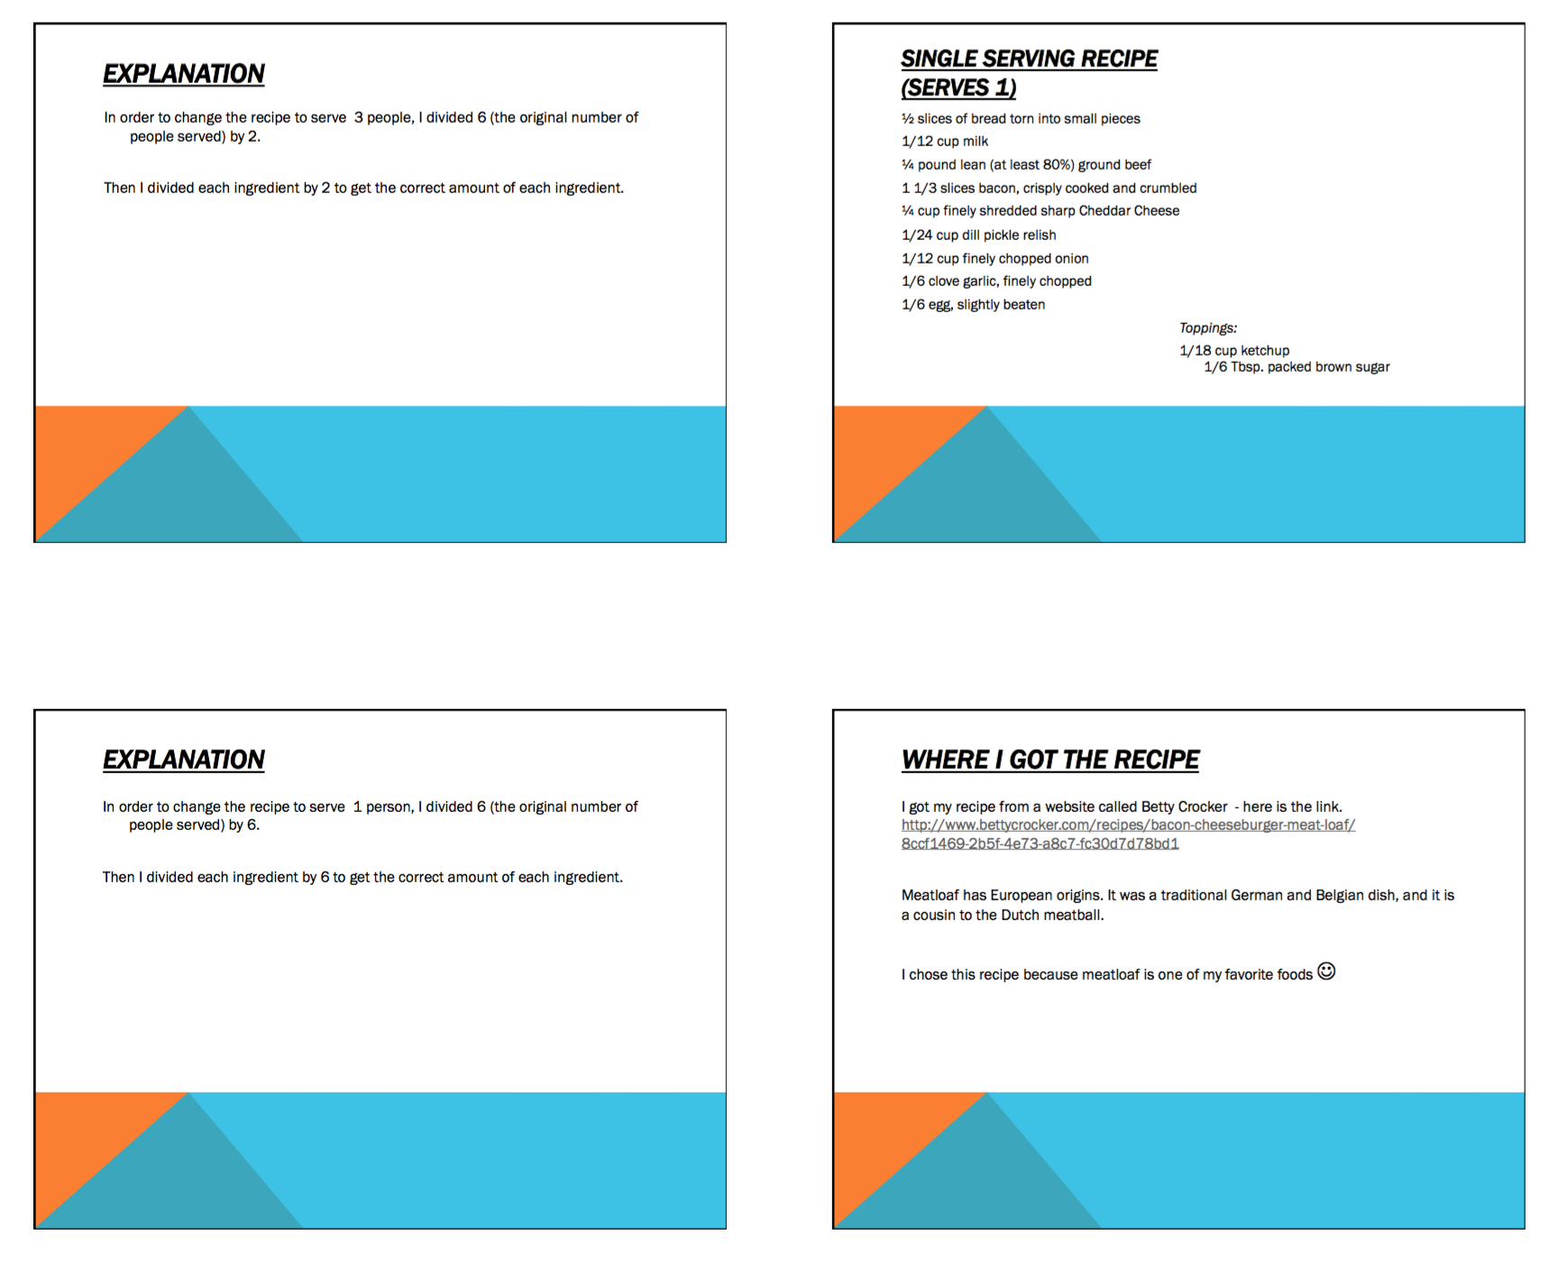

Source(s):

