Amid Smog Wave, an Artist Molds a Potent Symbol of Beijing’s Pollution
Beijing has been swamped for days in a beige-gray miasma of smog, bringing coughs and rasping, hospitals crowded from respiratory ailments, a midday sky so dim that it could pass for evening, and head-shaking disgust from residents who had hoped the city was over the worst of its chronic pollution.
But “Brother Nut,” a performance artist, has something solid to show from the acrid soup in the air: a brick of condensed pollution.
For 100 days, Brother Nut dragged a roaring, industrial-strength vacuum cleaner around the Chinese capital’s landmarks, sucking up dust from the atmosphere. He has mixed the accumulated gray gunk with red clay to create a small but potent symbol of the city’s air problems.

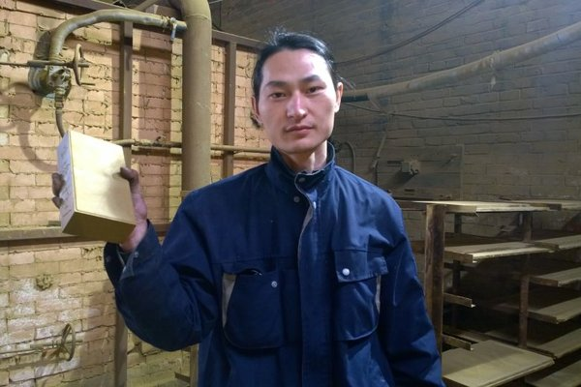
Brother Nut, in a brick factory in Tangshan, Hebei Province, with his unfinished brick of dust and red clay. “In smog like this,” he said, “There’s no escaping.” CreditDong Dalu/CFP

“Dust represents the side effects of humankind’s development, including smog and building-site dust,” he explained in an interview on Tuesday. “When I first arrived in Beijing, I wore a hygienic mask for a few days, but later I stopped. In smog like this, there’s no escaping.”
Reports in the Chinese news media about his “Project Dust” have coincided with the worst smog in more than a year across northernChina, and Brother Nut — Jianguo Xiongdi in Mandarin Chinese, as he insists on calling himself — has catapulted to instant fame in this city, where people talk about ups and downs in PM2.5 air pollution with the same familiarity that the English reputedly discuss rainfall.
“Nearly everyone in Beijing would have a brick in their stomachs. Older people, maybe five,” said one of over 4,000 often-rueful comments on an online photo gallery of Brother Nut’s project.
“If all of the dust in Beijing was collected together, it would be enough to build the world’s biggest environmental protection bureau,” said another.
The wave of smog across northern China arrived shortly before the start on Monday of negotiations in Paris, where governments hope to settle on a new agreement to reduce the greenhouse-gas pollution causingglobal warming. Much of that smog originates from the same coal-fire boilers, vehicle exhausts and industrial plants that pump out carbon dioxide, the main greenhouse gas.
But Brother Nut,34, smirked at suggestions that he might become a spokesman for efforts to clean up the environment. His intention was philosophical, he said.
“What I’ve done is like Sisyphus rolling his giant stone,” he said. “There’s no use, but it can make more people think about this issue. It’s a spiritual thing.”
Even without Brother Nut’s inspiration, many people in Beijing and other smog-afflicted cities have been upset about the latest inundation.
The Chinese government has promised to clean up the pollution, especially PM2.5, the tiny particles that can cause respiratory illness and other health problems. For much of this year, the air across Beijing and other cities has been cleaner, perhaps also partly thanks to a slowdown in industrial production.
But the new onslaught of smog has brought complaints from residents that local governments in Beijing and other cities were complacent and ill prepared for the pollution buildup in static winter air. The capital issued an “orange alert” — the second-highest pollution warning — for the first time since February 2014.
Brother Nut said he was no expert on PM2.5 pollution or its ill effects.
But feeling inspired to do something about the air quality, he bought a vacuum cleaner with rechargeable batteries and starting roaming the city with it in July.
He dragged the machine close to Tiananmen Square, the National Center for the Performing Arts, the China Central Television tower and other landmarks. In this usually security-sensitive city, the police were sometimes curious, but he was not harassed, he said.
Some onlookers failed to fathom his artistic purpose and mistook him for a high-tech street sweeper, he said.
“Some people thought, ‘Wow, Beijing’s really awesome,’” he said. “‘Now they’ve got air cleaners like this.’ They asked me how much money I made. Some thought I was selling vacuum cleaners.”
He also encountered a real street sweeper, he said, and “he asked me to vacuum a bit, and I did.”

