Capitalism vs. Socialism vs. Communism
What’s the Difference?

Capitalism and socialism are somewhat opposing schools of thought in economics. The central arguments in the socialism/capitalism debate are about economic equality and the role of government: socialists believe economic inequality is bad for society and the government is responsible for reducing it via programs that benefit the poor. e.g. free public education, free or subsidized health care, social security for the elderly, higher taxes on the rich. On the other hand, capitalists believe that government does not use economic resources as efficiently as private enterprise and therefore society is better off with the free market determining economic winners and losers. This lack of government involvement in the economy is called “laissez faire” (literally “let it be”)

The U.S. is widely considered the defender of capitalism and large parts of Scandinavia and Western Europe are socialist democracies. However, the truth is every developed country has some programs that are socialist.

Capitalism:
At its root, capitalism is an economic system based on three things: wage labor (working for a wage), private ownership of the means of production (things like factories, machinery, farms, and offices), and production for exchange and profit (you pay for what you get). While some people own means of production, or capital, most of us don't and so to survive we need to sell our ability to work in return for a wage.

The Laws of Economics According to Capitalism:
The law of self-interest: People work for their own good
The law of competition: competition forces people to make a better product
The law of supply and demand: Enough goods would be produced at the lowest possible price to meet demand in a market economy

In terms of government involvement in the economy, capitalists believe in the principle of “Laissez-faire economics, which means to "let it be". Therefore, capitalism is opposed to government intervention in economics because capitalists believe it is inefficient. Rather, a free market produces the best economic outcome for society. Govt. should not pick winners and losers.
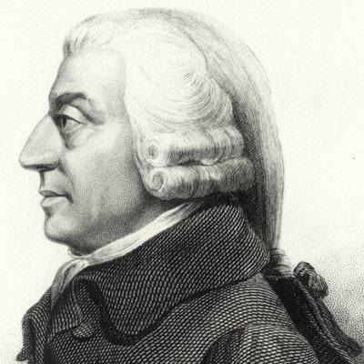

Influential Leader: Adam Smith is often identified as the father of modern capitalism. In his book, Wealth of Nations, he discusses the importance of division of labor and free trade, the limits on government intervention, all signify the moment when economics transitions to the “modern.”

Socialism
Socialism is an economic system where the means of production, such as money and other forms of capital, are owned by the state (the government) or public. Under a socialist system, everyone works for wealth that is, in turn, distributed to everyone. Under capitalism, you work for your own wealth. A socialist economic system operates on the premise that what is good for one is good for all. Everyone works for their own good and the good of everyone else. The government decides how wealth is distributed among the people.

In a socialist economy, the government provides for the people. The taxes are usually higher than in a capitalist system. There may be government-run health care and a complete system of government-operated education. It is a misconception that people do not pay for these services. They do pay for them through higher taxes. Socialist systems emphasize equal distribution of wealth among the people.
Communism

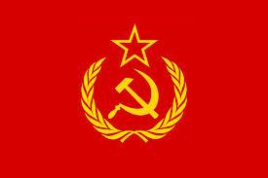
In a way, communism is an extreme form of socialism. Many countries have dominant socialist political parties but very few are truly communist. The key differences between socialism and communism are due to the fact that socialism is simply an economic system, while communism is both a political/governmental system and an economic system. The second main difference between socialism and communism is that within communism the distribution of goods and services takes place according to the individual's needs, while in a socialist system, goods and services are distributed based on individual efforts (e.g. paying taxes). Finally, within a socialist system, capitalism CAN exist (e.g. privately owned companies), while in a communist system capitalism CANNOT exist.

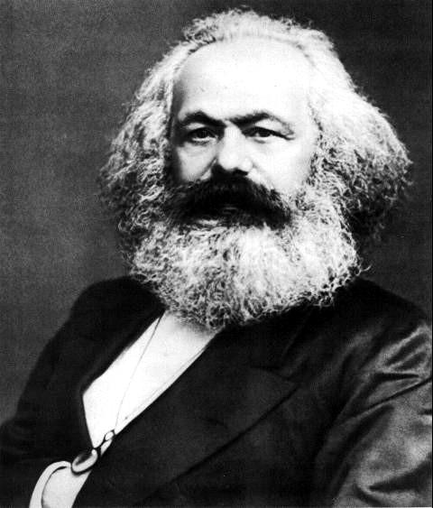
Influential Leader in the development of Socialist and Communist theory:
German economist, philosopher, and revolutionist, and one of the most original and influential thinkers of modern times, Karl Marx produced much of the theory of modern socialism and communism. In his publication the Communist Manifesto, Marx declared that all history was the history of class struggles. Under capitalism, the struggle between the working class and the business class would end in a new society, a communist one.

