Name___________________________ Period_________
Warm Up: Vocabulary Matching
1)  2)  3)  4)  5) | _________ ​tyrant  _________ imports  _________ boycott  _________ massacre  _________ propaganda | - To stop buying or using the goods or services of a certain company or country as a protest  - A cruel and oppressive ruler  - A brutal killing of a bunch of people  - Misleading information to persuade others point of view  - To bring goods into a country from a different country.

DBQ Focus: Causes of the American Revolution
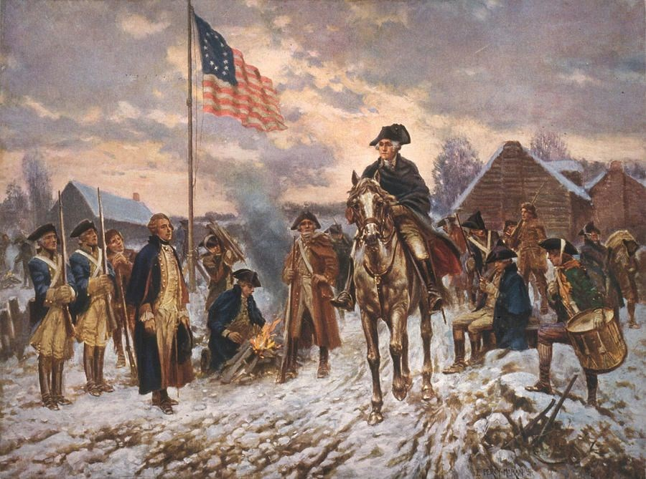
Document-Based Question Format
Directions: The following question is based on the accompanying Documents (The documents have been edited for the purpose of this exercise.) This question is designed to test your ability to work with and understand historical documents.

Historical Context:
In the 1760s, shortly after the conclusion of the French and Indian War, the British
Parliament passed a series of laws and taxes on the American Colonies. The colonists disagreed with Great Britain on the fairness of these laws and taxes, which led to conflict between the two sides. Eventually, this conflict erupted into the American Revolution.
Using the information from the documents and your knowledge of social studies, answer the questions that follow each document in Part A. Your answers to the questions will help you write the Part B essay in which you will be asked to…
- Describe at least two British laws or actions that the American colonists thought were​unfair and explain why the colonists thought these were unfair.
- Discuss at least two actions American colonists took to fight or resist British laws or actions.
Focus Question: What British laws or actions occurred that resulted in the colonist taking action to resist and request independence from England?
Speech by Patrick Henry to the Virginia House of Burgesses,
May 1765 in response to the Stamp Act

“We can under law be taxed only by our own representatives. We have no representatives in the British Parliament. So how can the British Parliament place this tax on us? It is simple; they cannot! The Stamp Act is against the law. We must not obey it… King George is a tyrant. He breaks the laws. He is an enemy of his own people.”

- Why does Patrick Henry feel that the Stamp Act and other British tax laws are unlawful?
_____________________________________________________________________________________________________________________________________________________________________________________________________________________

- How does Patrick Henry describe King George III?
_____________________________________________________________________________________________________________________________________________________________________________________________________________________
Organize your thoughts about Document 1:
British laws or actions that the American colonists thought were unfair. | Why did they believe it was unfair? | Actions American colonists took to fight or resist British laws or actions.
Graph showing colonial trade with Great Britain
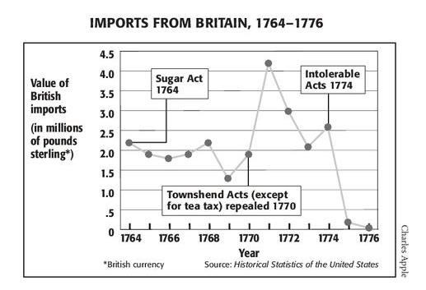
American colonist often organized boycotts of British goods in protest of taxation without representation. Boycotts were peaceful, everybody could support. Women used home spun cloth, made tea from pine needles, and bought only American made products. Other goods that could not be as easily produced in the colonies were smuggled in.

Britain relied on trade with the colonies to generate revenue. Boycotts were often an effective way to force the king to repeal these acts to protect British merchants.

- When did the greatest drop in British imports occur, and what event caused that decline?
_____________________________________________________________________________________________________________________________________________________________________________________________________________________
Organize your thoughts about Document 2:
British laws or actions that the American colonists thought were unfair. | Why did they believe it was unfair? | Actions American colonists took to fight or resist British laws or actions.
Stamp Act (1765) - enacted shortly after the French and Indian War
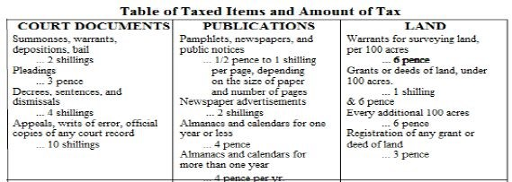
British Currency 1765:
12 Pence = 1 Shilling
20 Shillings = 1 Pound = 240 Pence
Why did Great Britain enact the Stamp Act?
_____________________________________________________________________________________________________________________________________________________________________________________________________________________

- Identify three goods taxed by the Stamp Act?
_________________________________, ____________________________________ & __________________________________

Organize your thoughts about Document 3:
British laws or actions that the American colonists thought were unfair. | Why did they believe it was unfair? | Actions American colonists took to fight or resist British laws or actions.

Document 4:​ Statement describing the Boston Tea Party- December 1773
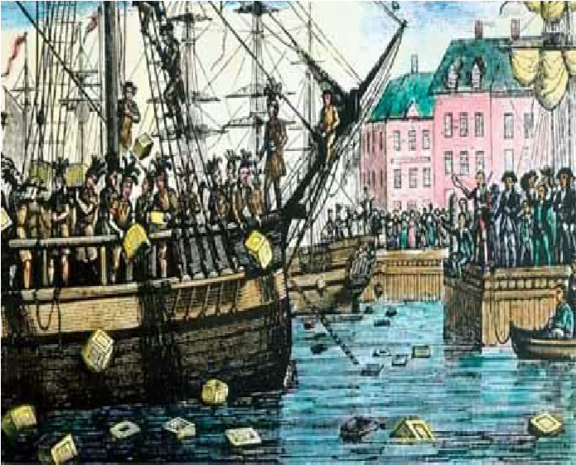
"It was now evening, and I immediately dressed myself in the costume of an Indian, equipped with a small hatchet, which I and my associates denominated the tomahawk, with which, and a club, after having painted my face and hands with coal dust in the shop of a blacksmith, I repaired to Griffin's wharf, where the ships lay that contained the tea. When I first appeared in the street after being thus disguised, I fell in with many who were dressed, equipped and painted as I was, and who fell in with me and marched in order to the place of our destination.
…We then were ordered by our commander to open the hatches
and take out all the chests of tea and throw them overboard, and we immediately proceeded to execute his orders, first cutting and splitting the chests with our tomahawks, so as thoroughly to expose them to the effects of the water.” G​eorge Hughes December 16, 1773

- What event is being described by George Hughes?
________________________________________________________________________
________________________________________________________________________

- Why did the colonists dump the tea into the Boston Harbor?
________________________________________________________________________
________________________________________________________________________

Organize your thoughts about Document 4:
British laws or actions that the American colonists thought were unfair. | Why did they believe it was unfair? | Actions American colonists took to fight or resist British laws or actions.

Document 5: Intolerable Acts 1774​
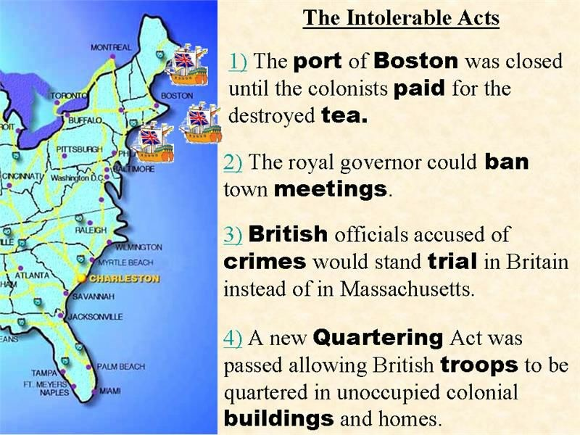
- Identify two laws created as part of the Intolerable Acts?
________________________________________________________________________
________________________________________________________________________
________________________________________________________________________

- What was the purpose of the Intolerable Acts?
________________________________________________________________________
________________________________________________________________________

Organize your thoughts about Document 5:
British laws or actions that the American colonists thought were unfair. | Why did they believe it was unfair? | Actions American colonists took to fight or resist British laws or actions.
Document 6: Paul Revere’s print of The Boston Massacre 1770​

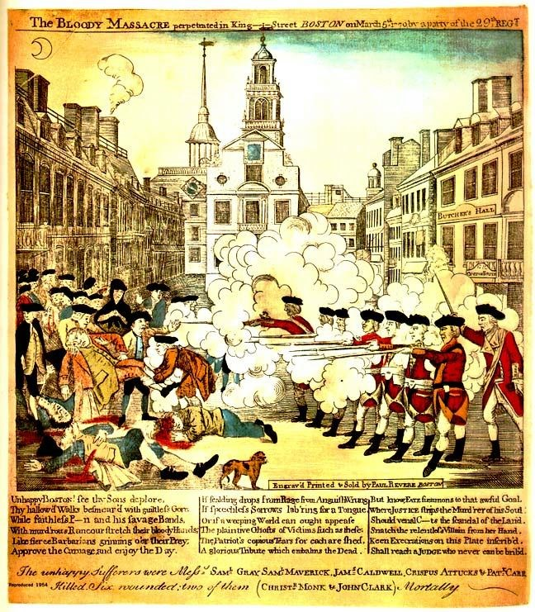
Due to many colonist protesting the increase in taxes and Quartering Act, Britain sent more soldiers to control the colonists. A crowd in Boston grew to about 50 people to protest the British. People yelled and threw rocks and snowballs at the British soldiers. The Redcoats shot into the crowd because they were frightened. Eleven people were shot and five died.

Paul Revere was advertising his prints for sale in the
Boston newspapers, three weeks after the occurrence March 5, 1770. Revere's historic engraving is propaganda rather than historical fact. Patriotic propaganda as seen here, called the incident a massacre to stir up feelings against the British government. He did this so more people would fight for independence.

10) What was Paul Revere’s purpose of calling the incident in Boston a “massacre?”
________________________________________________________________________
________________________________________________________________________
________________________________________________________________________

Organize your thoughts about Document 6:
British laws or actions that the American colonists thought were unfair. | Why did they believe it was unfair? | Actions American colonists took to fight or resist British laws or actions.

