Latin American Independence Movements
Aim: How did the revolutionary spirit in Europe and North America impact Latin America?
Do Now: Read the excerpt and examine the images below and answer the questions that follow.
Latin American Independence
"We came to serve God and to get rich." So said the conquistador, Bernal Diaz del Castillo, about the Spanish conquest of the Americas. In their search for gold and souls to save, Spain created an empire that extended as far north as Colorado and as far south as Patagonia in Southern Chile. This empire lasted for over 300 years. Then, between the years 1811 and 1830 one Spanish colony after another- Uruguay, Paraguay, Chile, Mexico, Ecuador, the United Provinces of Central America, Peru, Bolivia, Columbia, and Venezuela - declared their independence from Spain.
Why did Latin Americans become unhappy with Spanish rule? One major complaint was that the Spanish were unwilling to share political power. The Spanish crown appointed viceroys, or governors, who ruled the Spanish colonies. Even after several generations of colonial rule, viceroys and other government officials always came from Spain and rarely consulted with leaders who had always lived in the Americas.
Another annoyance was Spain's economic policies. Spain believed the purpose of the colonies was to build the wealth of the mother country. Under the economic system known as mercantilism, the Spanish officials took the majority of the profits from resources they found in the Americas.
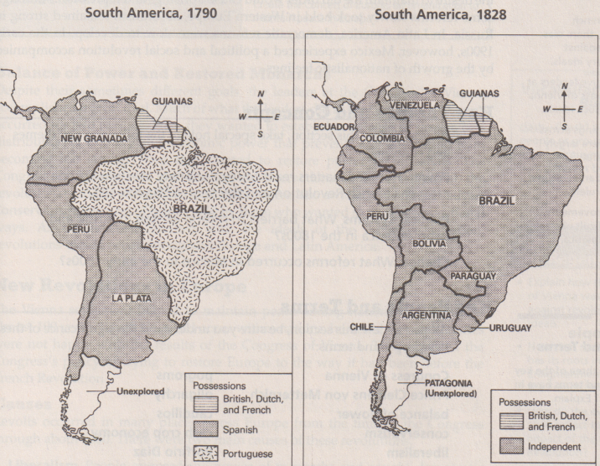
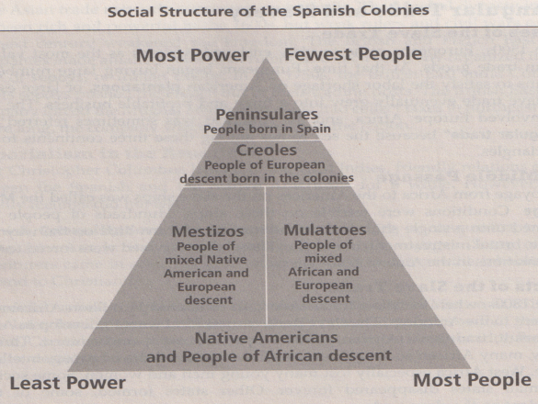
Despite these political and economic grievances, we know from the historical record that as late as 1800 there was little revolutionary activity in Latin America. Then, however, something happened. In 1808, Napoleon Bonaparte's French army invaded Spain, removed the Spanish king from the throne, and replaced him with Napoleon's brother. Because Spain was up to its elbows in trouble, it could not pay proper attention to its colonies. This created an opening for leaders like Simon Bolivar, Juan de San Martin, and Father Miguel Hidalgo. Wasn't this the perfect time for Latin American colonies to remove Spanish authority and declare their independence?
A big question was what this independence would look like. Bolivar, San Martin, and Hidalgo were all Creoles, born in America but of pure Spanish blood. As much as they wanted to be rid of the Spanish they were always uneasy about the racial mix of people who made up the rest of the Latin American population - slaves, free blacks, mulattos, mestizos, not to mention the Spanish-born pureblooded peninsulares. With this mixed population, creating a new country with a stable government, a strong economy, and a sense of nationhood was a real challenge.

1. Which countries on both sides of the Atlantic experienced revolutions during the late 18th and early 19th centuries?
The United States, France, Haiti

2. What were the major complaints of Latin American revolutionaries in regards to Spanish rule?
The major complaints of the Latin American revolutionaries included the Spain’s refusal to consult with people in America about how to run the colonies and their exploitation of Latin American resources.

3. How did Napoleon's invasion of Spain influence independence movements in Latin America?
When Napoleon invaded Spain, Spain started a six-year war with France that wrecked its economy and social system, and changed the government. This made it hard for Spain to stop a revolution in its colonies.

4. How was the social structure in Latin America similar to that of pre-revolutionary France? How was it different?
The social structure in Latin America was similar to that of pre-revolutionary France in that the least members of society had the most power. Social classes were also based on birth, rather than distinction. However, in Latin America, social classes had more to do with ethnicity than role in society.
Leaders of the Revolutions in Latin America
Father Miguel Hidalgo- Father Miguel Hidalgo was a Mexican priest who was also a nationalist. Born to a Creole family, he resented the power that was given to the peninsulares. On September 16, 1810, Hidalgo rang a bell in his hometown, calling the members of his church to the churchyard. There he delivered a famous speech calling on peasants to fight for their independence against the Spanish peninsulares. He shouted, “Death to bad government and death to the Spaniards.” Father Hidalgo would be arrested and executed for his role in rallying revolutionary actions. However, the Mexican independence movement had already begun. In 1821, Mexico finally won its independence from Spain and Father Hidalgo became known as the Father of Mexican Independence.

Father Miguel Hidalgo | - Born to a Creole family, he resented the power that was given to the peninsulares.  - Father Hidalgo would be arrested and executed for his role in rallying revolutionary actions.  - In 1821, Mexico finally won its independence from Spain and Father Hidalgo became known as the Father of Mexican Independence.
Símon Bolívar | - Born to a wealthy Creole family in what is now Venezuela  - Bolívar would become the most influential leader in the South American independence movement.  - Led military campaigns against the Spanish in present day Venezuela, Colombia, Panama, Ecuador, Peru, and Bolivia.
José de San Martín | - He was a former soldier in the Spanish army.  - He was the leader of the independence movement in Argentina and Chile.  - José won many great victories over the Spanish and even fought side by side with Símon Bolívar
Símon Bolívar-Born to a wealthy Creole family in what is now Venezuela, Símon Bolívar would become the most influential leader in the South American independence movement. Known simply as “the Liberator”, this nationalist led military campaigns against the Spanish in present day Venezuela, Colombia, Panama, Ecuador, Peru, and Bolivia. Bolívar had hoped that these South American nations could join together as one large nation. He never saw this dream come true but did live to see these countries liberated from Spain.

José de San Martín- San Martín was born in Argentina. This nationalist was a former soldier in the Spanish army but when he returned home to find his nation was rising up against Spanish rule, he quickly become the leader of not only the independence movement in Argentina but also in Chile as well. José won many great victories over the Spanish and even fought side by side with Símon Bolívar for a time. After helping many South Americans win their independence José de San Martín returned to Europe, where he lived until his death in 1850.

As you read each article, pick out the three most important facts about each person and fill in the chart:
Latin American Independence Movements
Place the following sentences in the correct corresponding category based on whether they were a long-term of immediate cause or a long-term or immediate effect of the Latin American Independence movements.

- By 1825 most of Latin America became independent.
- Creoles, Mestizos, and Indians resent European rule.
- 18 republics set up.
- American and French Revolutions.
- Europeans dominate Latin America.
- Toussaint L’Ouverture leads slave revolt in Haiti.
- Enlightenment ideas.
- Ongoing efforts to bring prosperity and democracy to people in Latin America even today.
- Napoleon invaded Spain and threw out the Spanish king.
- Efforts continue to stabilize democratic governments and economic independence.
- Revolutionary leaders come forward.
- Growth of nationalism.

Long-Term Causes

- Europeans dominate Latin America.
- Enlightenment ideas.
- American and French Revolutions.
- Growth of nationalism.

Immediate Causes

- Creoles, Mestizos, and Indians resent European rule.
- Napoleon invaded Spain and threw out the Spanish king.
- Revolutionary leaders come forward.
- Toussaint L’Ouverture leads slave revolt in Haiti.

Immediate Effects

- By 1825 most of Latin America became independent.
- 18 republics set up.

Long-Term Effects

- Efforts continue to stabilize democratic governments and economic independence.
- Ongoing efforts to bring prosperity and democracy to people in Latin America even today.

