You Must Make Paragraphs!

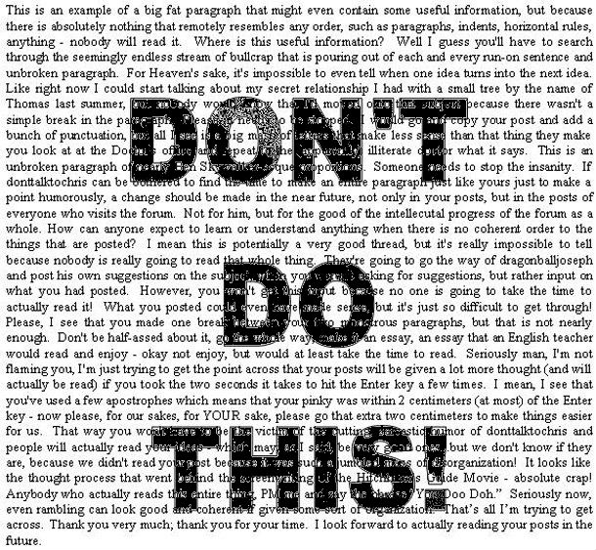
Paragraphs are important. Without paragraphing, the text looks imposing and overwhelming, like a giant wall of words! Yikes!

When a paragraph ends, the reader has a chance to pause and reflect. Additionally, the beginning of the new paragraph signals to the reader that a change is taking place.

Start a new paragraph when....

- a new character enters the scene

- a new person begins to speak

- the topic changes

- the setting changes

- a new event occurs

- time moves forward or backward

- dramatic effect is needed for emphasis

Narrative: Paragraphing

Directions: Review the rules for paragraphing. Then read the following story excerpt. It won’t be easy to read, as it is one giant paragraph! Decide where the paragraphs should go, and place a paragraph symbol ( ) at the spot where a new paragraph should begin and explain why you needed a new paragraph ther
Explain how reading the paragraph made you feel. Why are paragraphs important? ____________________________________________________________________________________________________________________________________________________________________________________________________________________________________________________________________________________________________________________________________________
Reason

The Magic Thread
Once there was a widow who had a son called Peter. He was a strong, able boy, but he did not enjoy going to school and he was forever daydreaming. "Peter, what are you dreaming about this time?" his teacher would say to him. "I'm thinking about what I'll be when I grow up," Peter replied. "Be patient. There's plenty of time for that. Being grown up isn't all fun, you know," his teacher said. But Peter found it hard to enjoy whatever he was doing at the moment, and was always hankering after the next thing. In winter he couldn’t enjoy sledding and skating, and he yearned for it to be summer again, and in summer he looked forward to the skating, sledding, and warm fires of winter. Often he wandered through the forest, dreaming of the future. While he was there he would lay down on the soft forest floor in the warm sun, his hands behind his head, staring up at the sky through the distant treetops. One hot afternoon as he began to grow sleepy, he heard someone calling his name. He opened his eyes and sat up. Standing before him was an old woman. In her hand she held a silver ball, from which dangled a silken golden thread. "See what I have got here, Peter," she said, offering the ball to him. "What is it?" he asked curiously, touching the fine golden thread. "This is your life thread," the old woman replied. "Do not touch it and time will pass normally. But if you wish time to pass more quickly, you have only to pull the thread a little way and an hour will pass like a second. But I warn you, once the thread has been pulled out, it cannot be pushed back in again. It will disappear like a puff of smoke. The ball is for you. But if you accept my gift you must tell no one, or on that very day you shall die. Now, say, do you want it?“ Peter seized the gift from her joyfully. It was just what he wanted. He examined the silver ball. It was light and solid, made of a single piece. The only flaw in it was the tiny hole from which the bright thread hung. He put the ball in his pocket and ran home. When he arrived home, he examined the silver ball again. The thread seemed to be creeping very slowly out of the ball, so slowly that it was scarcely noticeable to the naked eye. He longed to give it a quick tug, but dared not do so. Not yet.
Using Transition Words in Narrative Writing

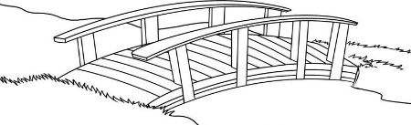
Transition words and phrases are like bridges
that connect the story elements. They help move

the plot sequence smoothly, they show setting and time shifts, and they emphasize important plot details.

Show Location:

around | near | south of | north of | beneath
By | throughout | east of | Against | close to
beyond | between | west of | Alongside | Toward
Inside | along | among | Outside | Over

Show Time and Sequence:

at the beginning | at the end | Yesterday | the next day
in the morning | in the afternoon | in the evening | later
in the past | in the future | the earliest | recently
at first | First | Second | after
immediately | Afterward | Finally | when
Before | During | After | meanwhile

Show Emphasis and Importance:

the best | for this reason | especially
the most important | Surprisingly | Truly
the least important | equally important | suddenly

Transitional Words and Phrases

Directions: Join the sentences using the transition words in the box.

Here are 11 separate sentences. See if you can use them in a paragraph by linking them with transitional words or phrases. You can choose from the words and phrases provided in the box on the right.

At last
But
During the day
Eventually
Finally
However
Immediately
So
Soon
Usually

- The sun was setting;
- It would be completely dark;
- The little rabbit didn’t go out at night;
- Tonight was different;
- She had found a nice carrot patch;
- She had spent a long time enjoying the carrots;
- She noticed it was getting dark;
- It was too late to get back to her burrow;
- She started looking for a place to shelter for the night;
- She found shelter in a hollow next to a log;
- She was able to settle down for the night.

_______________________________________________________________________________________________________________________________________________________________________________________________________________________________________________________________________________________________________________________________________________________________________________________________________________________________________________________________________________________________________________________________________________________________________________________________________________________________________________________________________________________________________________________________________________________________________________________________________________________________________________________________________________________________________________________________________________________________________
_____________________________________________________________________________________

Other Transition Words:
afterwards, also, as well as, at last, at the same time, before, first, for example, immediately, in fact, later, meanwhile, next, not only, once, otherwise, previously, then, therefore, too, usually.

