Why We Like to Be Scared: The Science Behind the Scream
By Dr. Robi Ludwig
TODAY
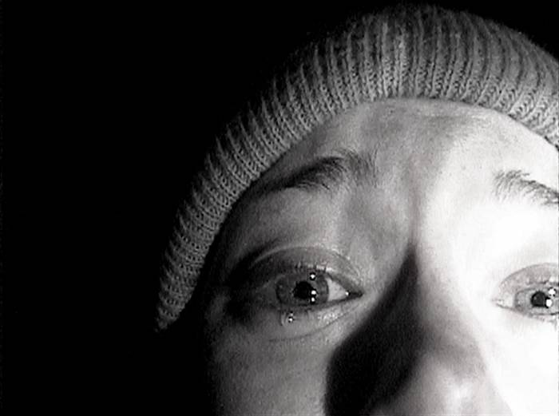
Mwaaaa-haaa-haaaa-haaaa…Halloween is coming near, and that means all the frightening images and costumes are taking center stage. But enjoying these scary situations is a slightly different topic. And as it turns out, many of us do.
Heather Donahue faces the camera in a scene from the 1999 horror film 'The Blair Witch Project.'

We like being scared and this is not a new phenomenon. As a culture, we seem to be craving these intense panic button experiences more and more. Why do we like being scared so much?
When we have the daylights frightened out of us our heart beats a little faster, we breathe a bit more intensely, perspire more and get butterflies in the pit of our stomachs. Experts know it’s not uncommon for people to want to push the envelope just to see just how much fear they can tolerate. There is a great sense of satisfaction when we can prove to ourselves we actually can handle more anxiety than we ever imagined we could.
There’s also a hormonal component when it comes to fear and enjoyment. The hormonal reaction we get when we are exposed to a threat or crisis can motivate this love of being scared. The moment we feel threatened, we feel increasingly more strong and powerful physically, and more intuitive emotionally. This charge to our physical and mental state is called an “adrenaline rush,” and as humans we are apparently hard-wired to be drawn to this type of feeling.
On a psychological level there’s an appeal to vicariously experience what’s forbidden, bizarre or dark. Horror films in particular allow us to explore the experience of fear in an enjoyable and safe way. They also allow us to identify with the bad guy without getting ourselves into too much trouble. Many of us have a need to expose ourselves to sensations which are different from our daily routine. This helps us to feel more stimulated by life. Identifying with the dark side of human nature can be quite cathartic for us as well.
Creepy stories help us to release strong emotions. Let’s face it, most of us, in our daily lives, don’t have a way to release these types of intense and unimaginable feelings (which is probably a good thing). There are benefits to let go of these pent up fears and let them run their course when we have the chance.
And while one person’s scary might be another person’s enjoyable, some of us are pre-destined from birth to choose a more terrifying life route. Personal pleasure can vary widely. So whether you’re facing your fears by doing something terrifying, like skydiving, or by watching a scary movie, remember either one can feel gratifying and rewarding.

Questions:
- Which conclusion is best supported by this text? (RI 7.1)
  - It is natural for people to attempt to avoid situations that may causes fear
  - The hormones released when people are afraid help to reduce stress
  - People watch scary movies or participate in extreme sports, like skydiving, because the fear allows them to push their limits and break outside of their ordinary routine
  - Creepy stories should be told to children to help them better understand their emotions

- What is the main idea of this passage? (RI 7.2)
  - Many cultures around the world include traditions, like Halloween, in order to celebrate fear
  - People enjoy experiencing fear because of the positive side effects
  - People are attracted to things which are dark and forbidden
  - Fear causes an adrenaline rush that makes people feel stronger

- What is the meaning of the word “vicariously” in the 5th paragraph? (L 7.4)
  - Experienced through imagined participation in the experience of others
  - Restricted; not allowed
  - Causing intense fear
  - Extremely realistic, life-like

- According to the text, what happens to the human body when the hormone adrenaline is released?
  - People are able to run much faster
  - People become stronger
  - People are better able to overcome their fear
  - People feel less stress and bored with their daily routine

- Psychologically, why is it good to experience fear? (RI 7.1)
  - It improves a person’s over mental health
  - It makes people stronger and more powerful
  - It releases tension and reduces stress
  - It allows people to safely connect to the darker side of human nature and release strong emotions

