World Map

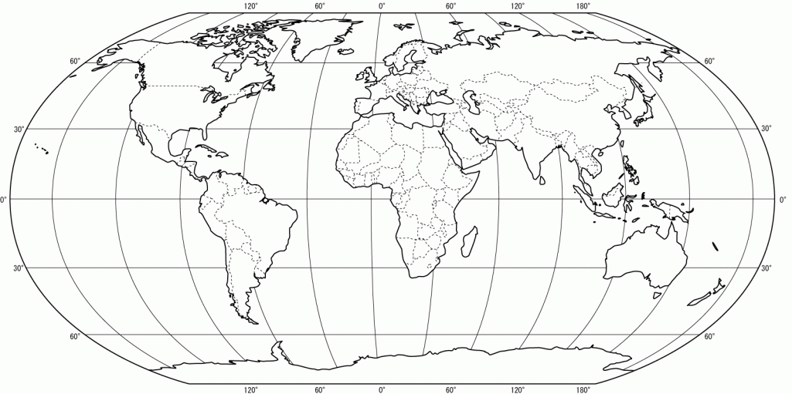
Map Labeling Activity
Directions:
- Label and color each of the seven continents accordingly:
-North America = Green
-South America = Red
-Africa = Yellow
-Europe = Purple
-Asia = Orange
- Australia = Dark Blue
-Antarctica = Pink

- Color all of the water light blue and label the following oceans:
- Atlantic
- Pacific
- Indian
- Arctic
- Southern

- Add the proper cardinal direction to each of the lines of latitude and longitude and label the following:
- Equator
- Prime Meridian
- International Date Line

